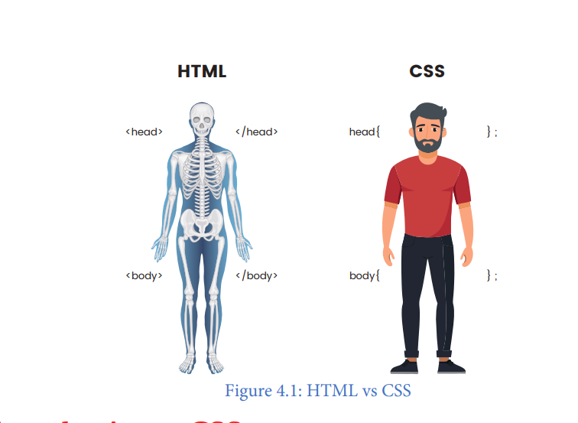

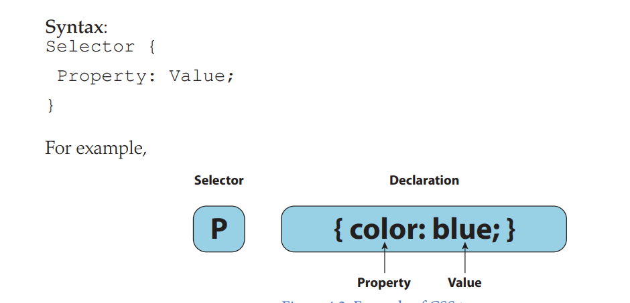

Types of CSS
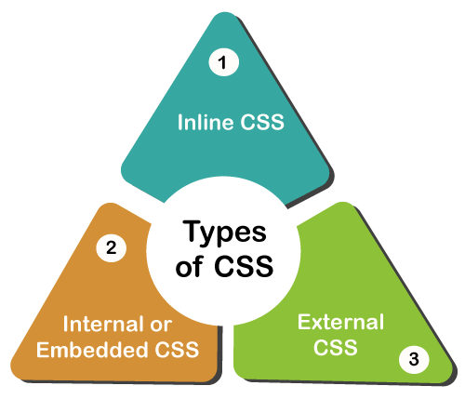
<html>

<head>

<title>Document</title>
</head>

<body>

<h1>rahil</h1>
<p style="color: black; font-family: Arial, sans-serif;">i am coding and robotics trainer</p>
</body>

</html>

<html>

<head>

<title>Document</title>
<link rel="stylesheet" href="style.css">

</head>

<body>

<h1>rahil</h1>
<p>i am coding and robotics trainer</p>
</body>

</html>

h1 {
color: red;
}

p {
color: blue;
}

